Find Mail Servers :-

1. Open CMD

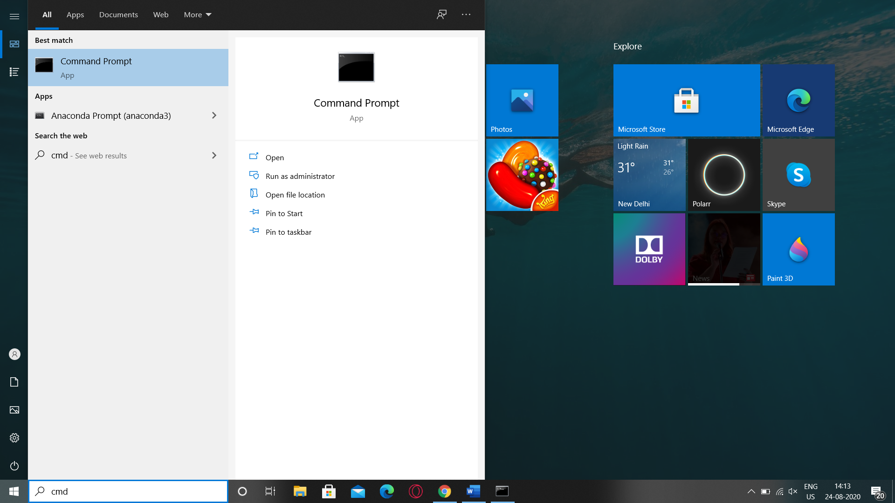

1. Type “nslookup” in CMD
2. Type “set type=mx” for mail servers

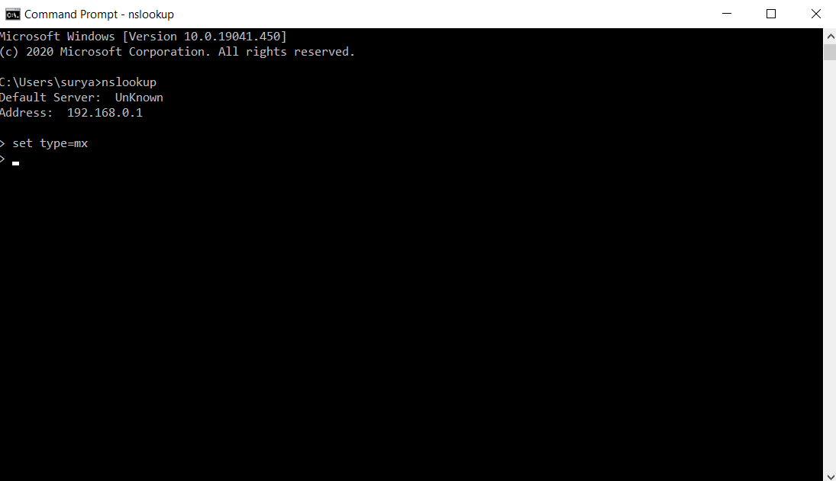

1. Type Ibm.com

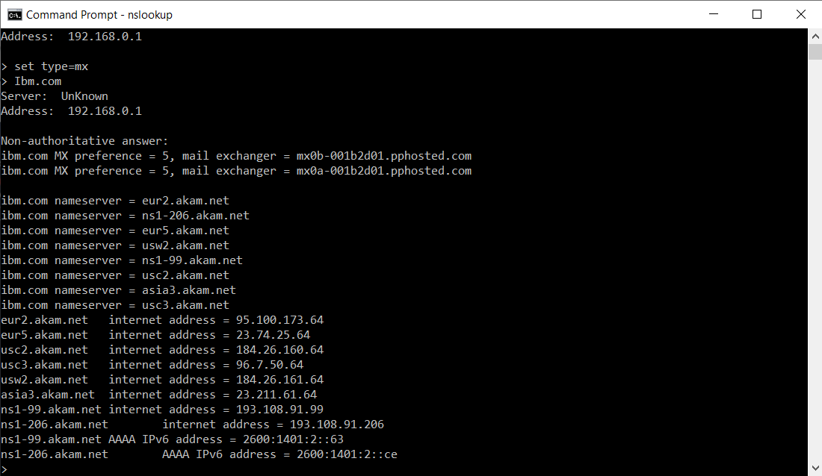

There are Total 2 Mail Servers of IBM.com

1. Type Wipro.com

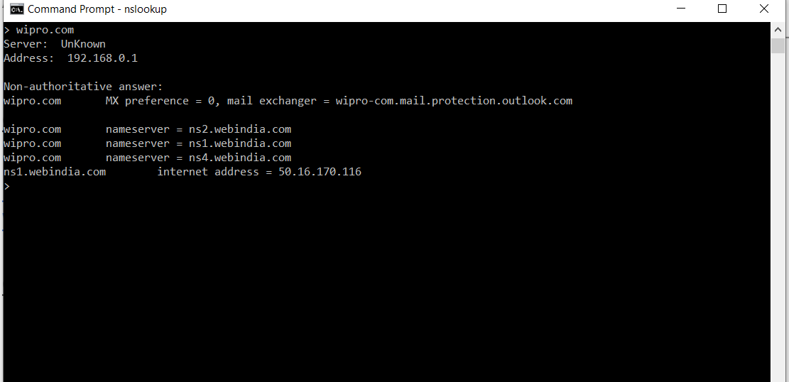

There are Total 1 Mail server of Wipro.com

Location of Email Server: -

1. Show Original For the mail you have received

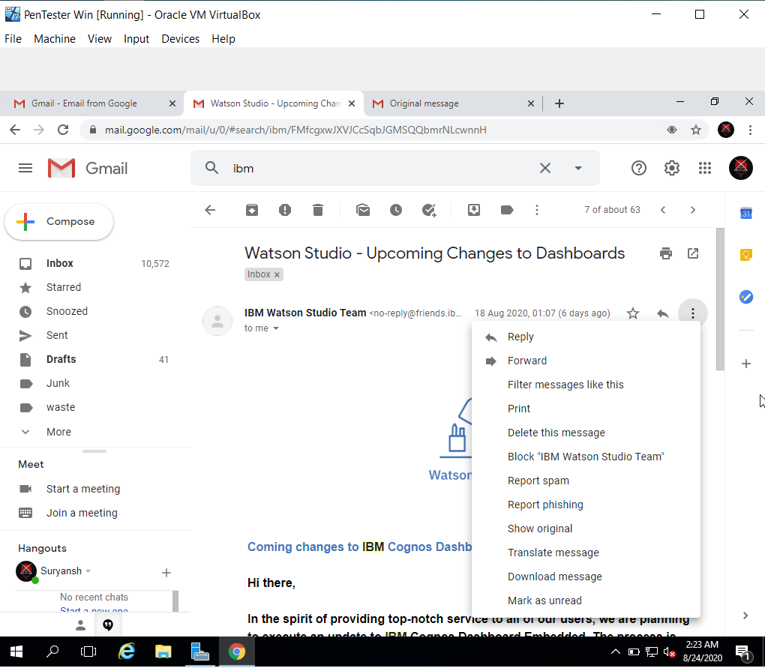

2)Copy Headers to clipboard

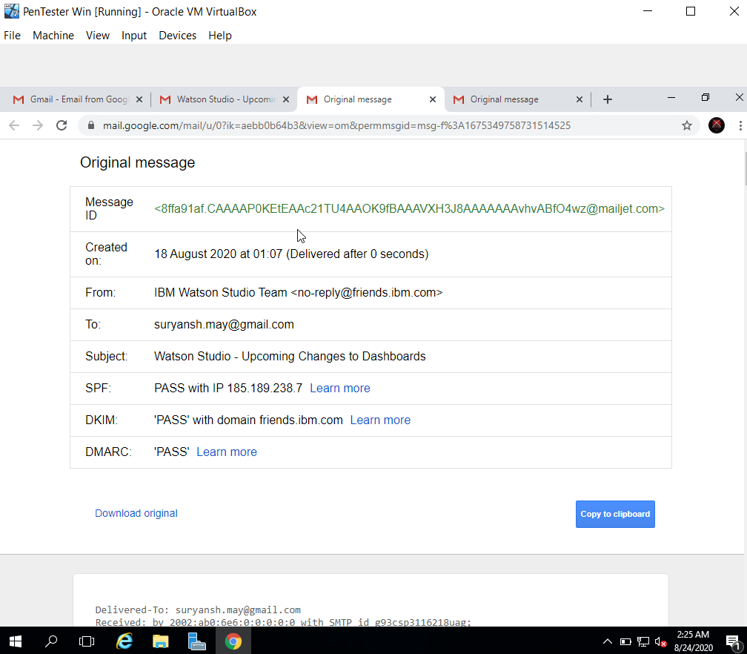

1. Run EmailTrackerPro

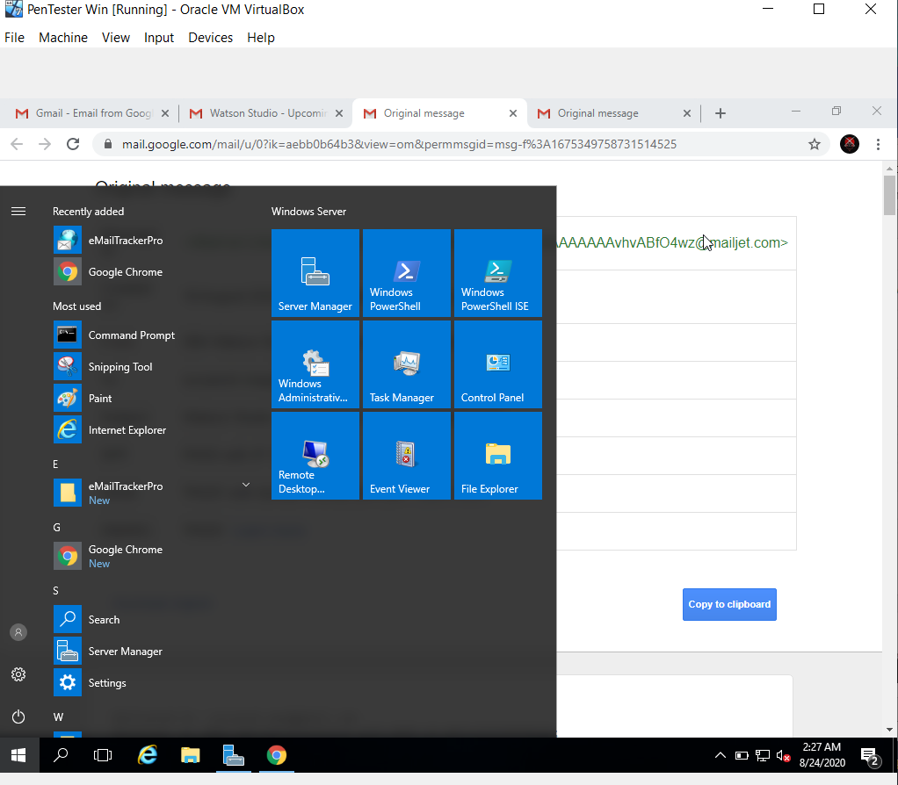

1. Click TraceReports Then TraceHeaders

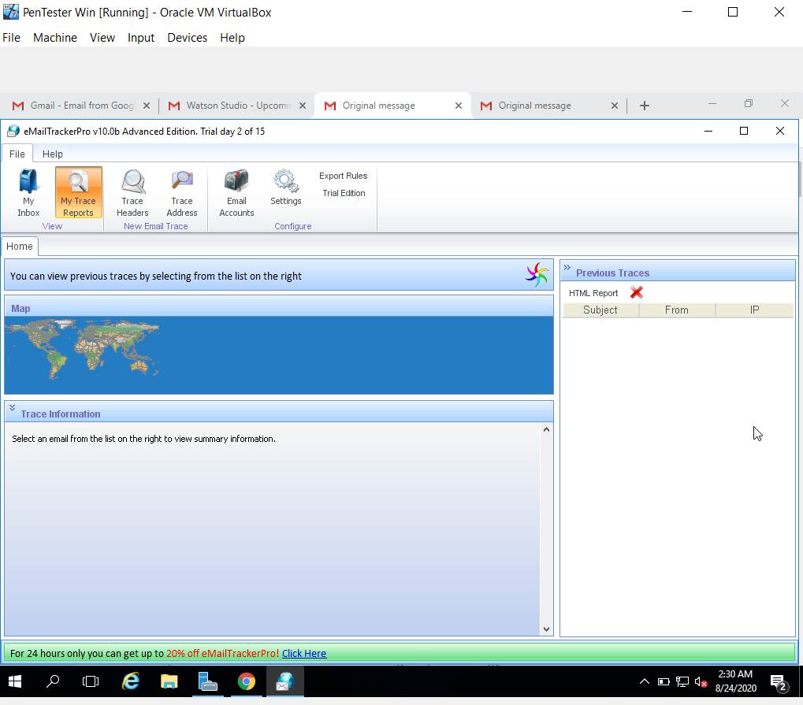

1. Paste the Headers in Trace an Email I have Received and Click Trace

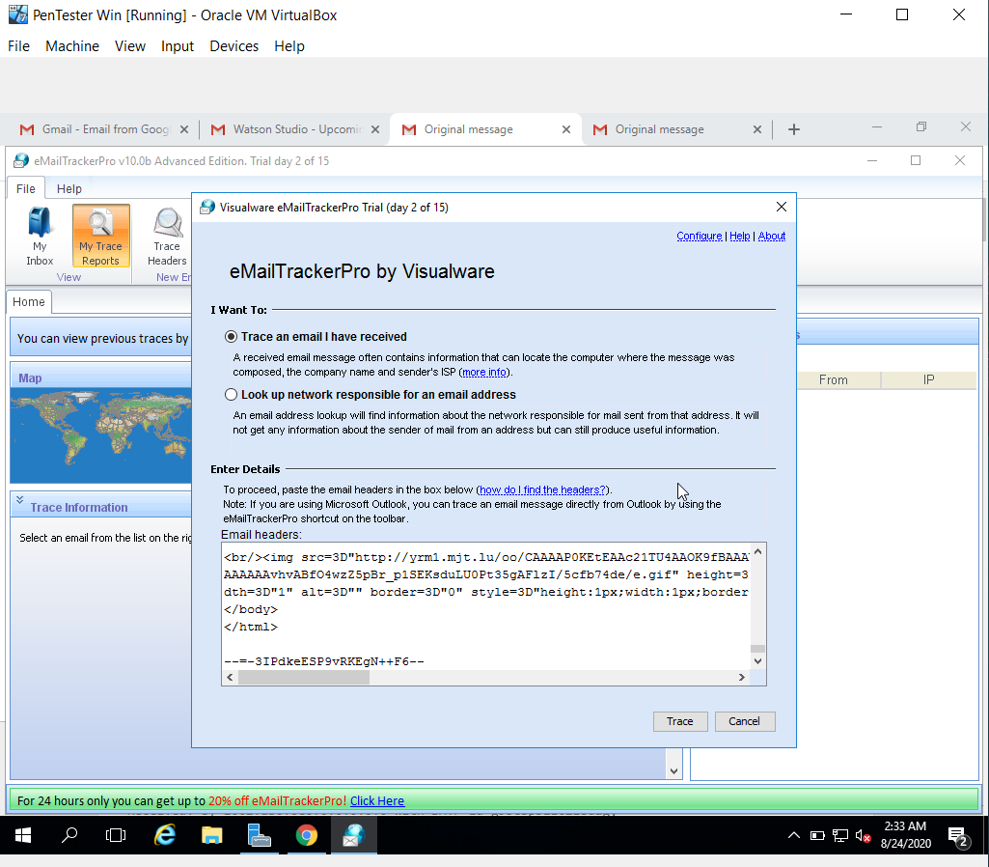

1. The Route and location of the Email Host will be located

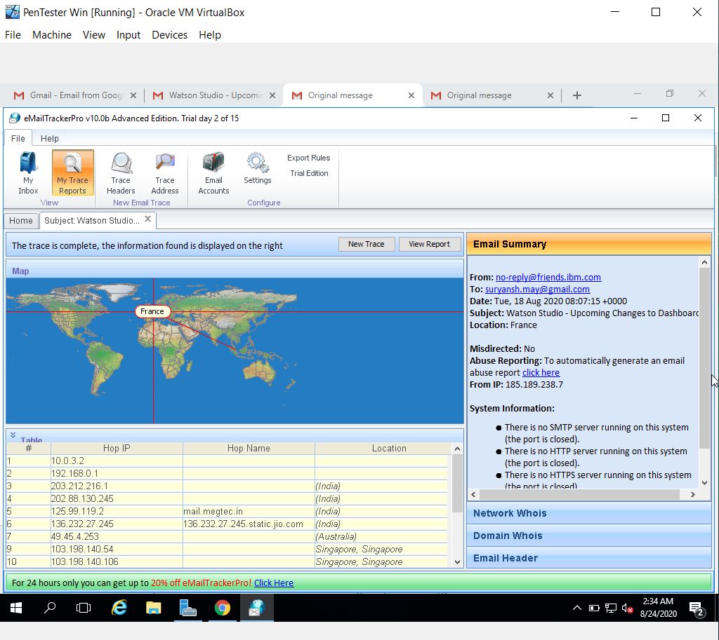

The email From IBM that I received is from France

Scan open Ports of 203.163.246.23

1. Open Terminal In Kali Linux

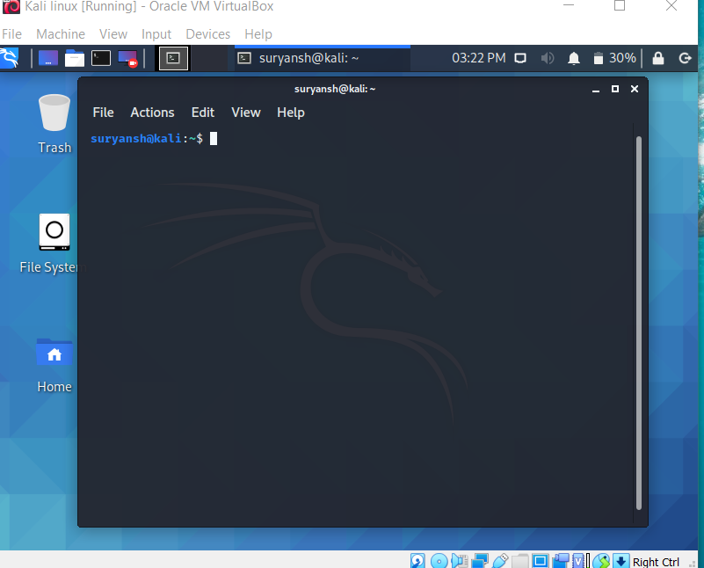

1. Type sudo su to become Super User and type the password for the user

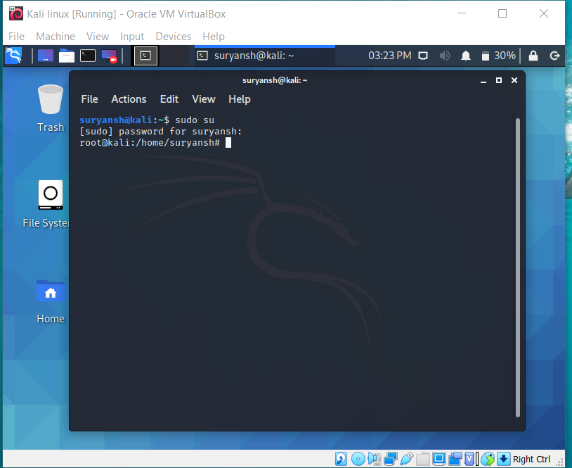

1. Type nmap -Pn -p1-65535 203.163.246.23 to scan for all ports in 203.163.246.23

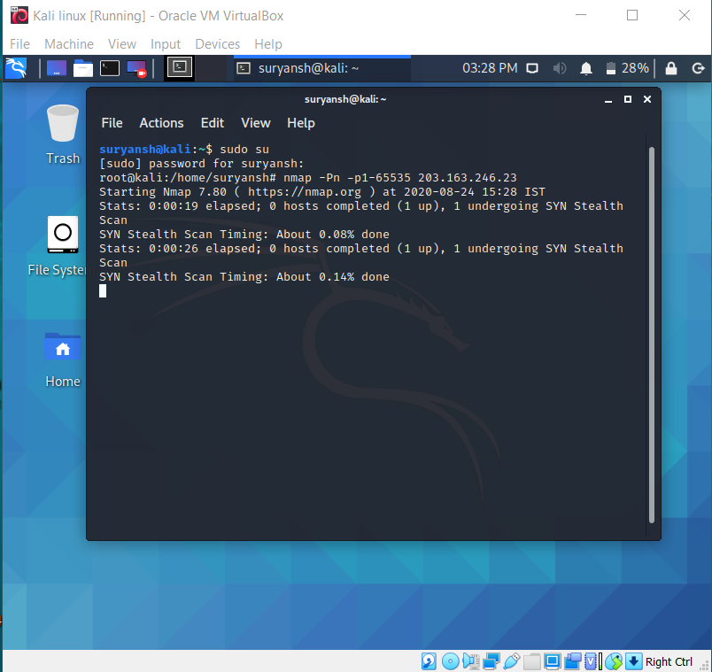

1. After The scan we can see which port is open and which is not open

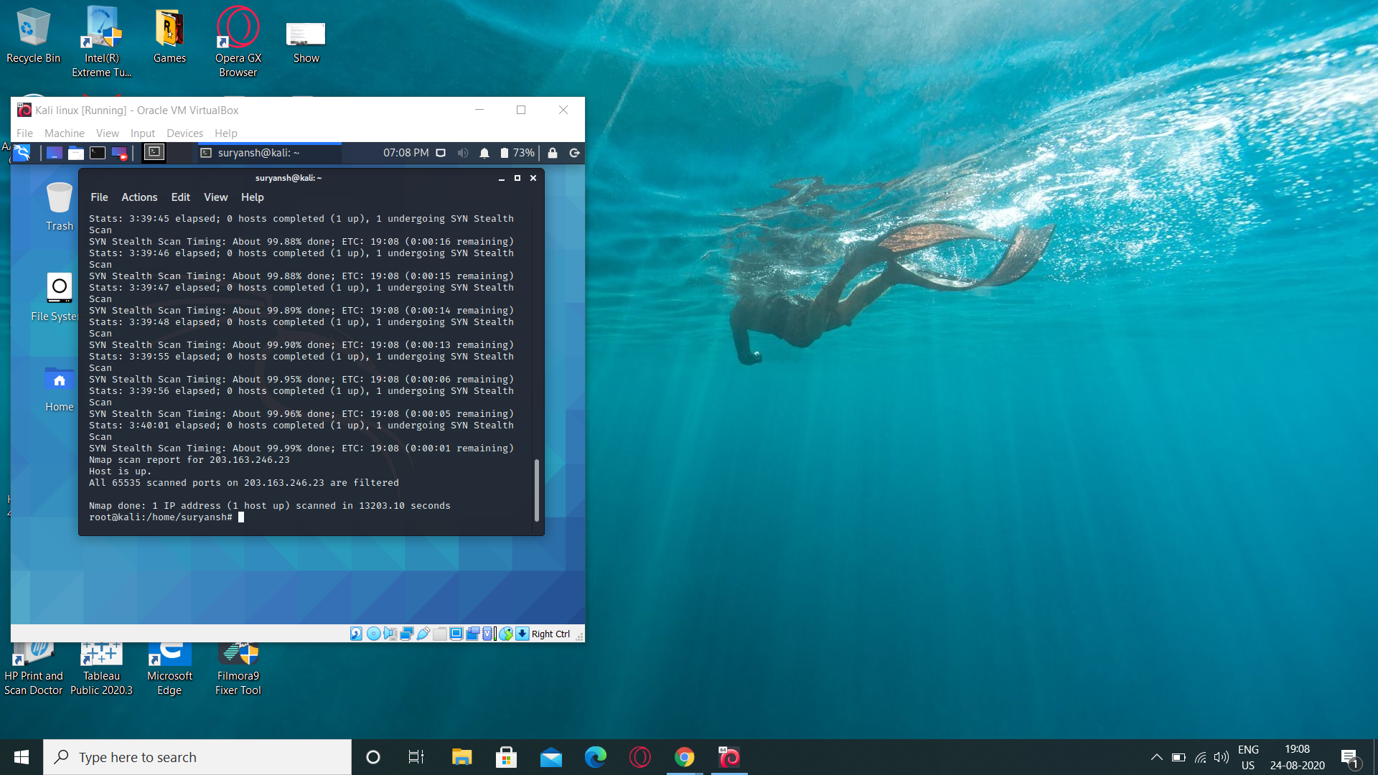

Scan using Nessus

1. Open Nessus Controller in Web
2. Click New Scan

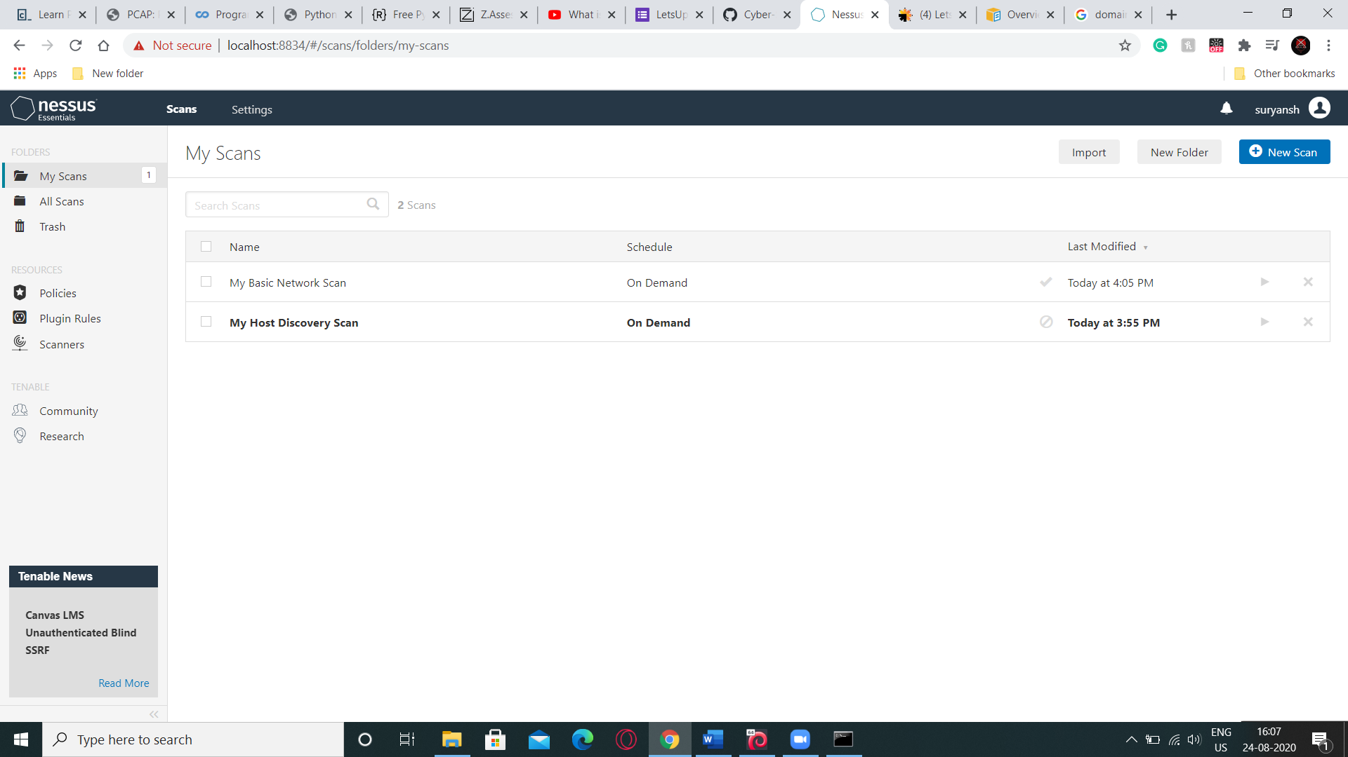

1. Click Advanced Scan

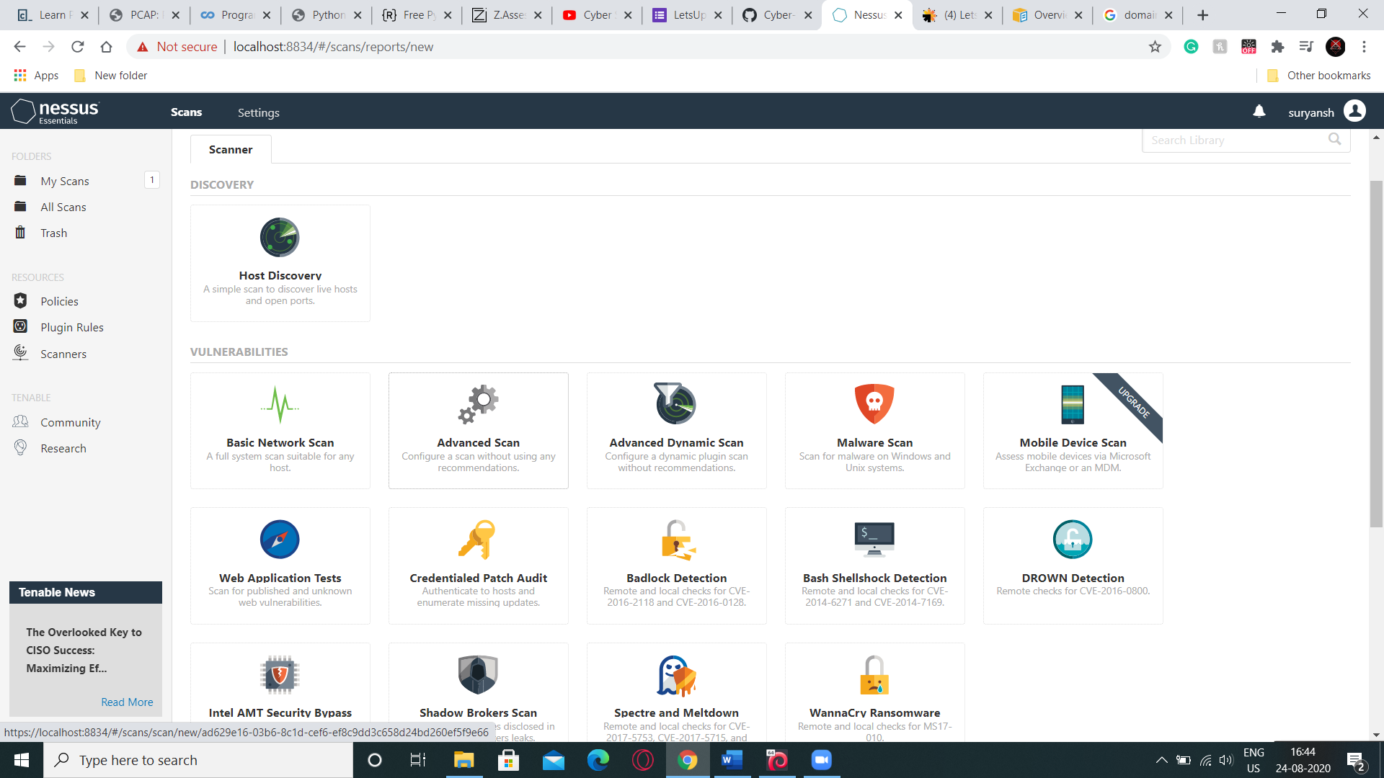

1. Type name as domain Controller and in Targets write your IP

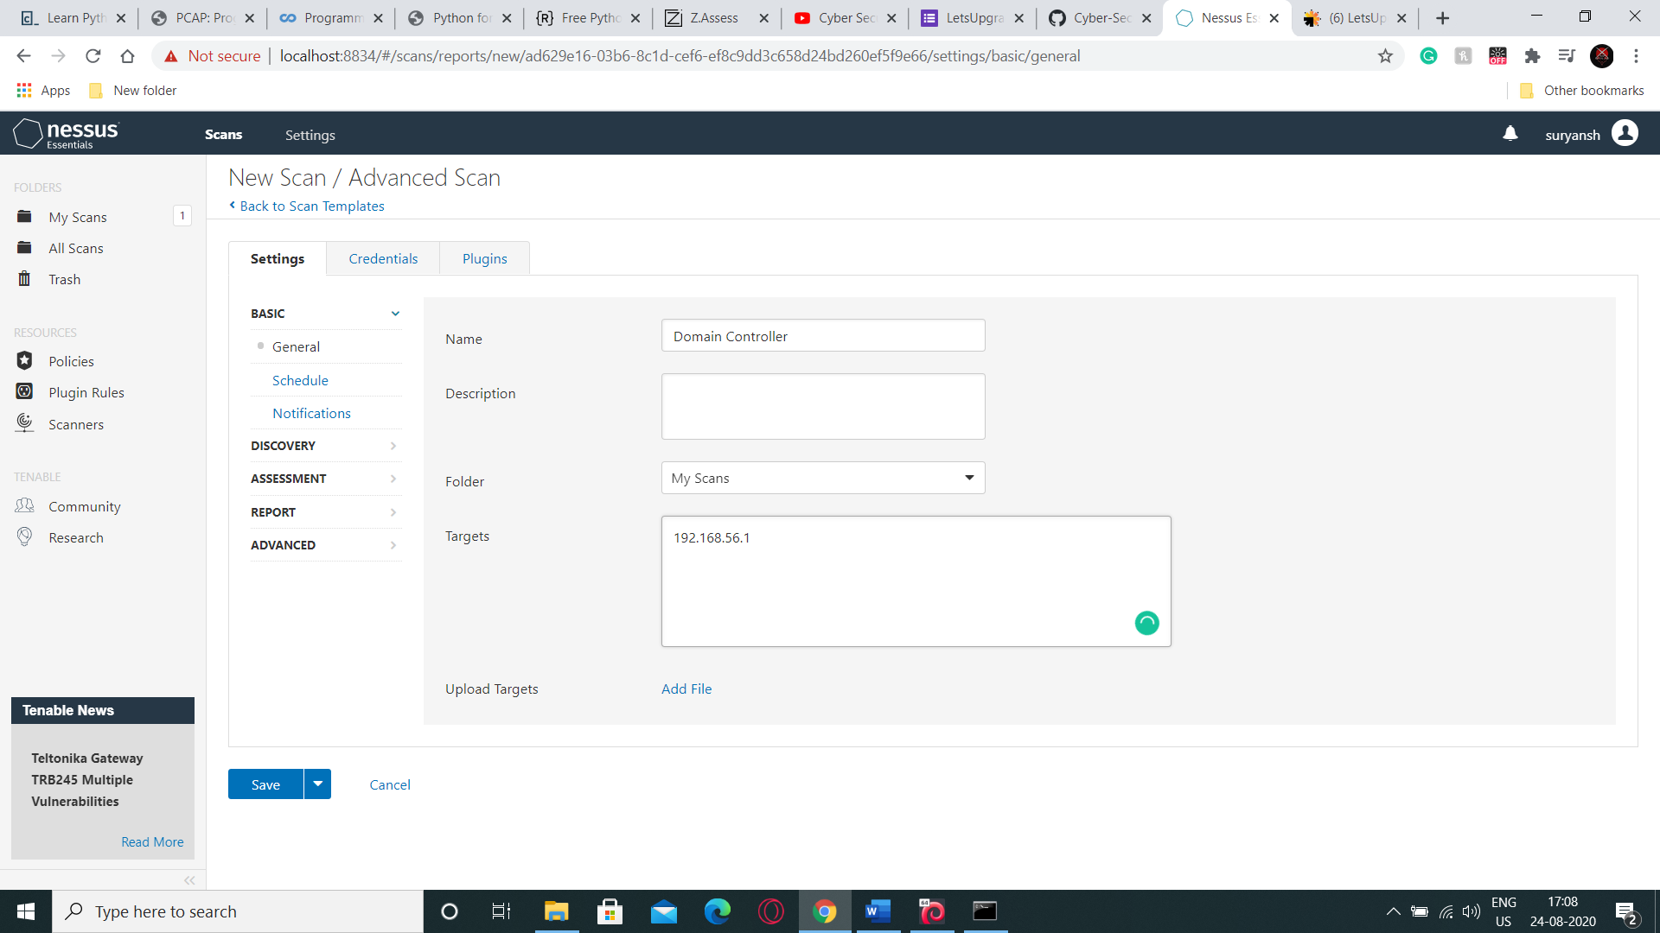

1. Now in credentials Enter username and Password with Domain name then click Launch

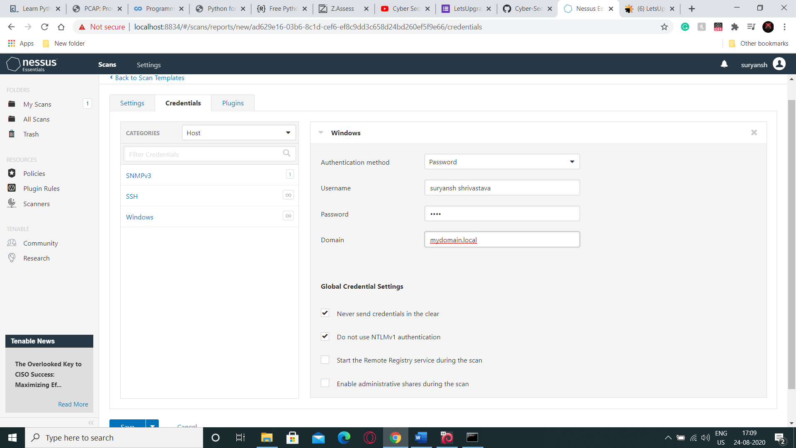

1. Wait for the process to get over

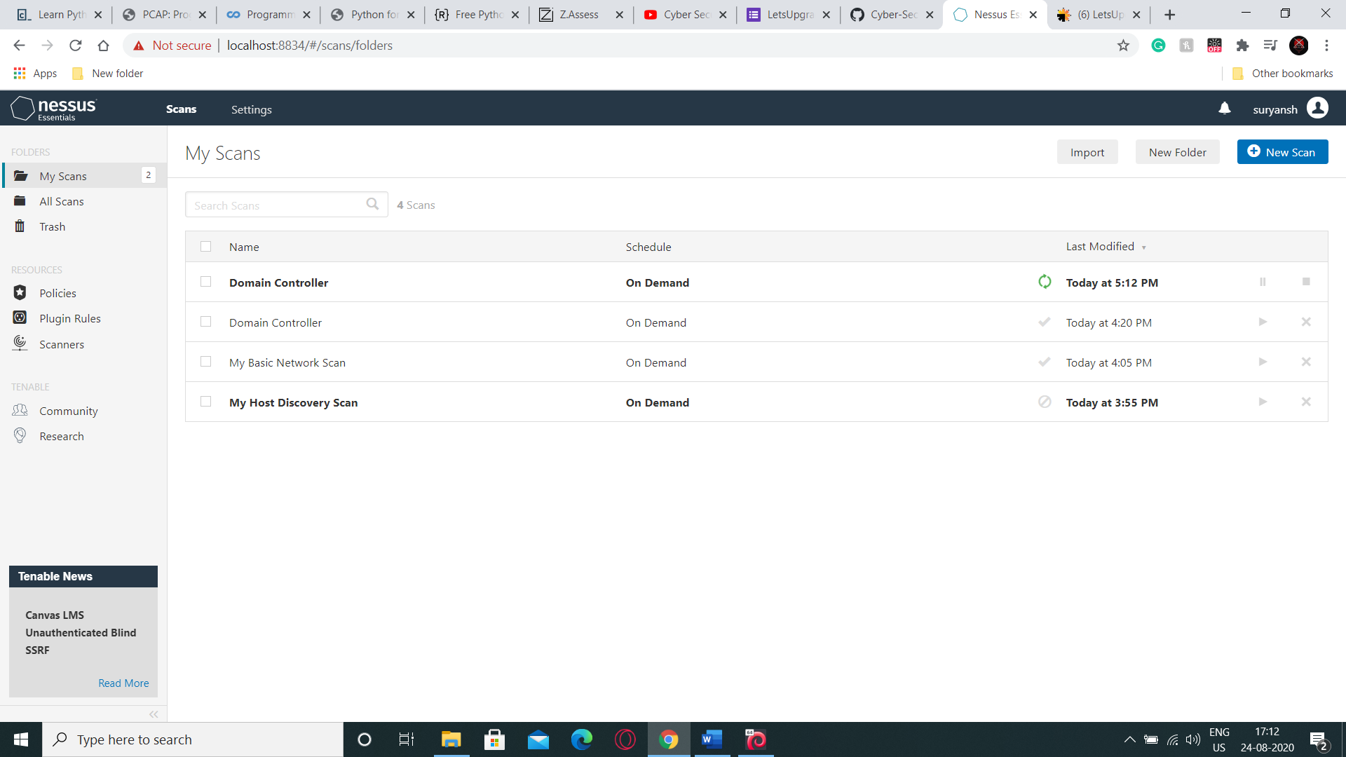

1. Clicking on the same will tell us of the Vulnerabilities of the IP

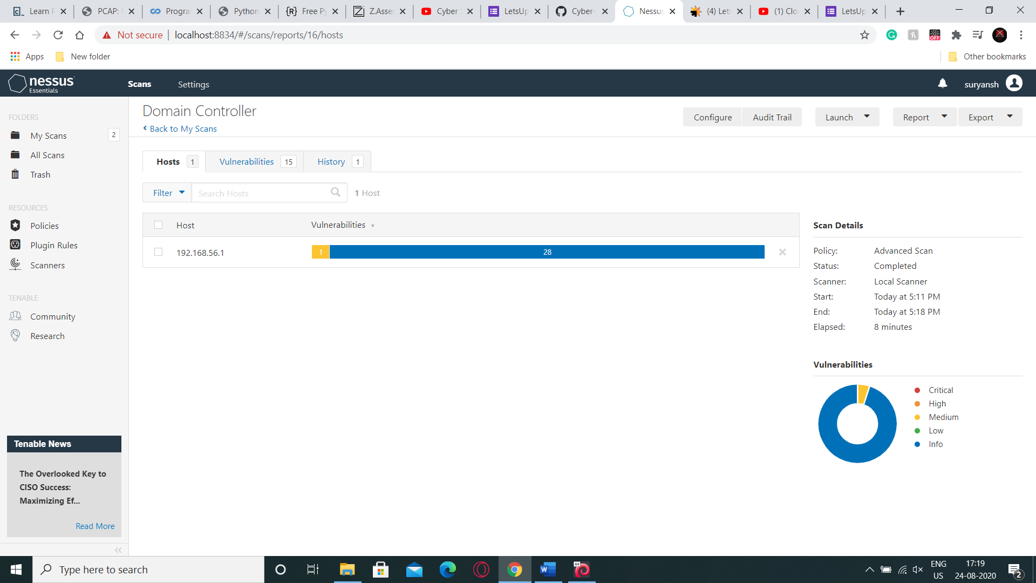

1. Create Report by clicking on Report then Html then create a Custom Report

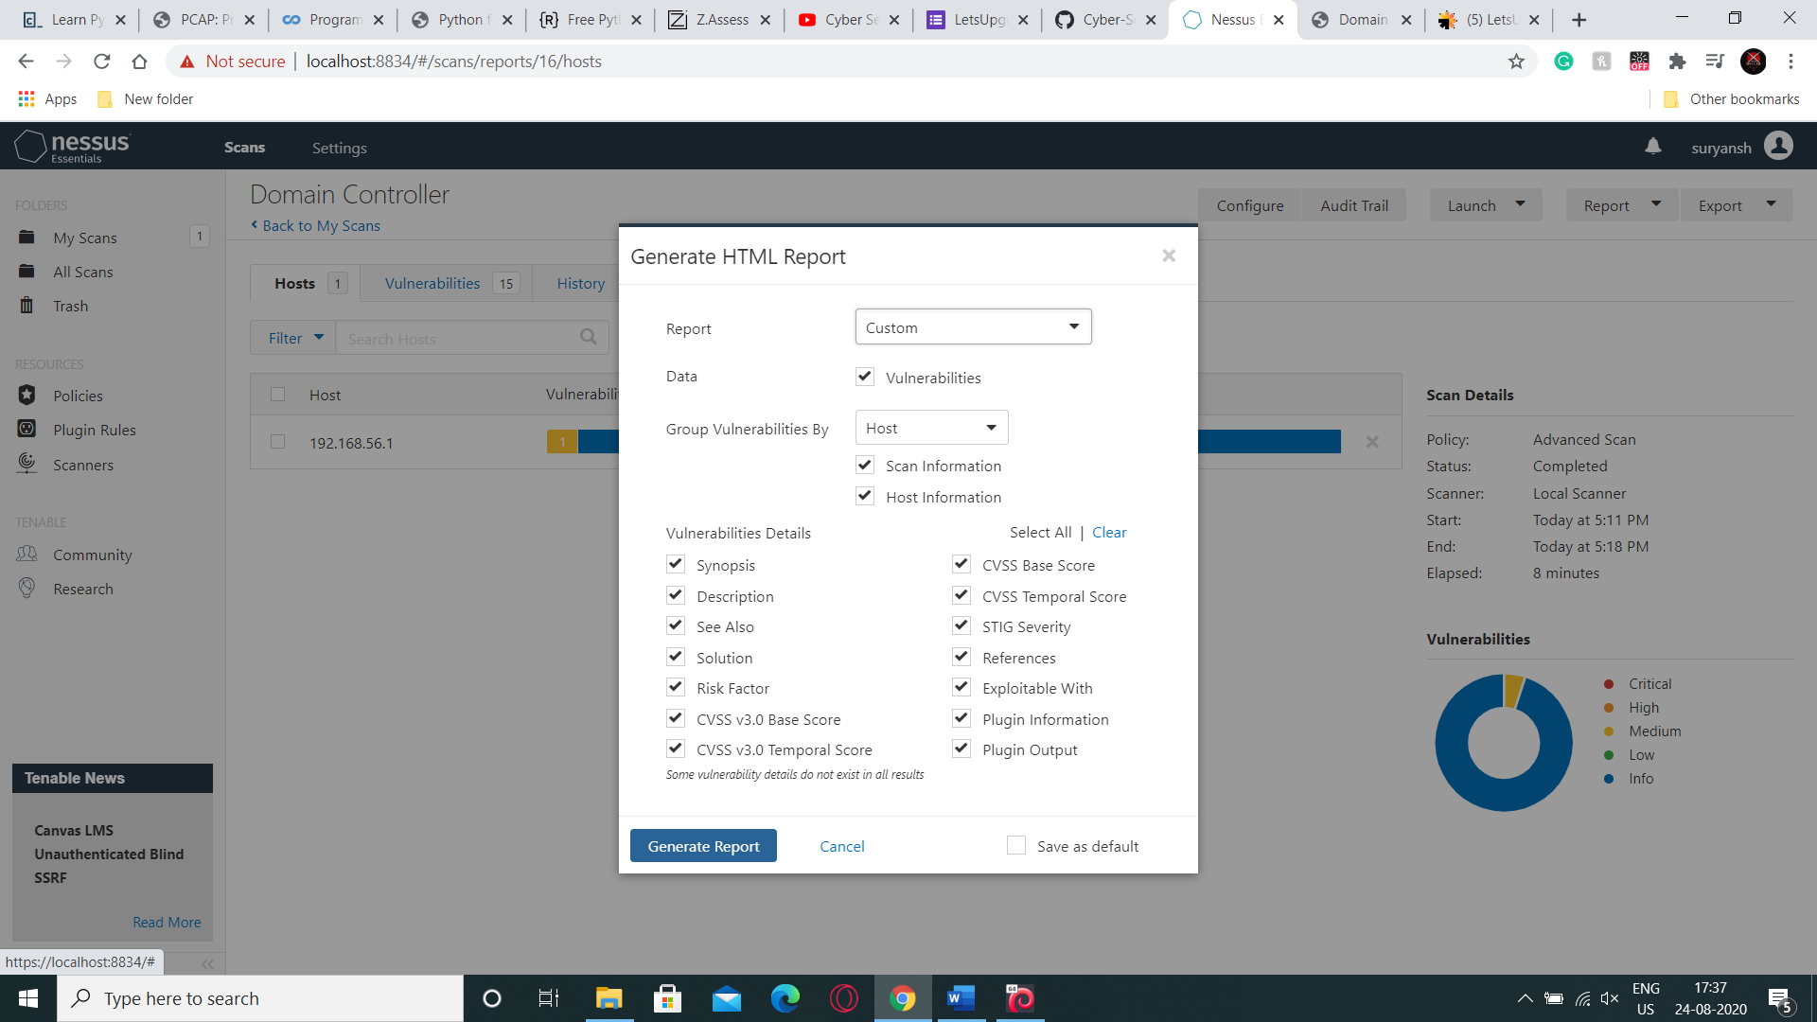

1. Your Report will be created with some suggestions how to fix these vulnerabilities.

